This is aimed at participants on events. For those filming for event videos please see additional document entitled ‘filming event videos’.

Words and images have the power to do good as well as harm. They can create or destroy.

We’ve been considering how photos and videos taken at events are used, and how sites like Facebook and YouTube can so easily make sensitive information very public. We want to try to make sure that no one is embarrassed or upset, and that no harm comes from things that are put online. We also want events to continue being safe and enjoyable.

Once photos and videos are out there on the internet, it can be impossible to regain control of them. We feel a responsibility to ask you to consider any potential issues before uploading. Ask yourself what the people in the photos might feel and who might be looking at them. Think about the impact that the image might have in the future and not just now. Remember that for many people, Quaker events are very personal experience which they may not want to broadcast to everyone. Some young people might, for their own safety may not want the events they attend to be broadcast, please also remember that they might find this hard to talk about. If you’re in any doubt, leave it out.

If you are embarrassed or upset, by an image that has been put online from the event by another participant or team member, try at first to resolve this with the person concerned, if this is not successful, then please let the staff member responsible for the event know.

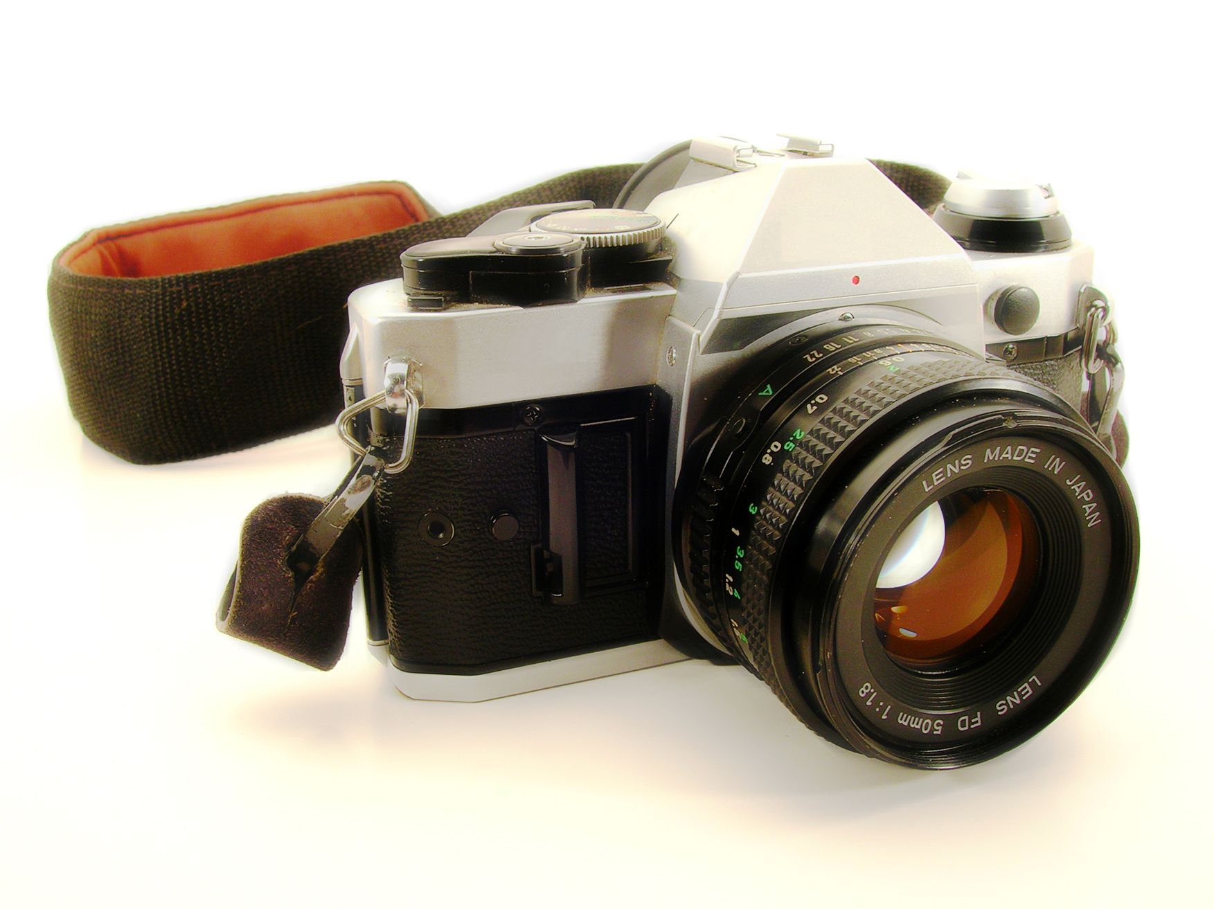
Following the event selected photos which have been taken by the event photographers are put onto Flickr. These images are public. Images that appear in publications e.g. the Friend and on the website are used in line with the consents you have given. We try to choose photos carefully, reflecting on the message that each image conveys and the permissions you have given. We only upload group pictures (not photos of individuals). If for any reason there is a photograph posted on Flickr that causes concern, please contact the member of staff responsible for the event and they will arrange for it to be removed or modified.

Where the BYM event is private and held on private land, BYM asserts its right to ensure that the use of photos and videos, during and after the event by staff, volunteers and participants is line with their image policy http://www.quaker.org.uk/event-and-activity-management-0

(This document is based on Yorkshire Friend’s Holiday School guidelines in relation to images taken at their event).

Page 1: Save the Children Focus on Images

