Initial Disclosure Reporting Form

This form is for use by the person who received the disclosure.
This form is confidential within the terms of the Area Meeting Safeguarding Procedures.

Note: Disclosures of abuse should be recorded as close to the time of the incident as possible. Please include as much detail as possible and record all information all information concisely. Record the disclosure verbatim. Do not try to interpret.
Completed by (name):
Event/premises:

Role at event/premises:
Contact details:
Address
Telephone number(s)
e-mail

1. Date and time of disclosure/incident causing suspicion:
2. Name and age of the young people or adults involved
3. Details of adult or young person (if any) named as perpetrator:
4. Name, age and contact details of any witnesses:
5. If person named in section 3 or 4 is a child or young person please give the names of their parents or legal guardians:
6. Please record details of the disclosure or the incident causing suspicion. In relation to disclosure, please do not interpret the information given to you. It is important that you use the same language as the child / young person / adult involved. Do not paraphrase or summarise. Please continue overleaf or on additional sheets if needed.
(Use the “Skin Map” as appropriate, but do not undress the person who made the disclosure, or ask them to undress.) Skin Maps (from Guidance to Churches)

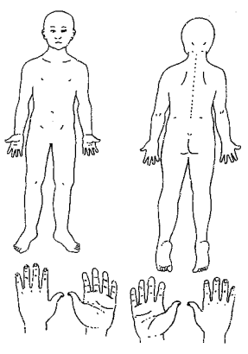
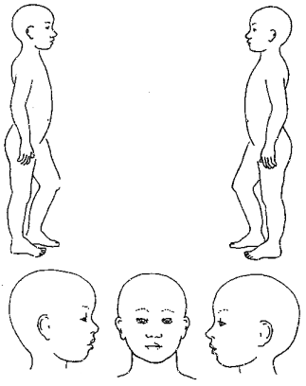
6. Details (continued)
6. Details (continued)
7. Action Taken (including person/people/organisations contacted)
Signed:

Date: | Time:
Name of the Safeguarding Coordinator to whom you pass this form:
Details of the Safeguarding Co-ordinator should be available on the premises or at the event.
Date form passed to Safeguarding Co-ordinator:

Signed by Safeguarding Coordinator:

Date: | Time:

This form should be stored in a secure place and considered in relation to the section of this document entitled Guidance on Confidentiality. All notes made at the time should be kept with this form

