This procedure applies to all Britain Yearly Meeting centrally managed work with children and young people (see http://www.quaker.org.uk/event-and-activity-management)

Head bump letter

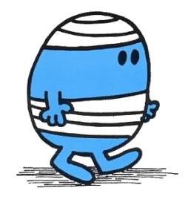
Dear Parent / Guardian of (participants name) ……………………………………………………………….

Your child/ward has sustained a head injury today at approximately……….am/pm and has been monitored since the accident and we have not identified anything that caused concern up to the end of the session. Please note that the head injury did not result in unconsciousness.

Details (including name of the first aider)………………………………………………............

……………………………………………………….…………………………………………

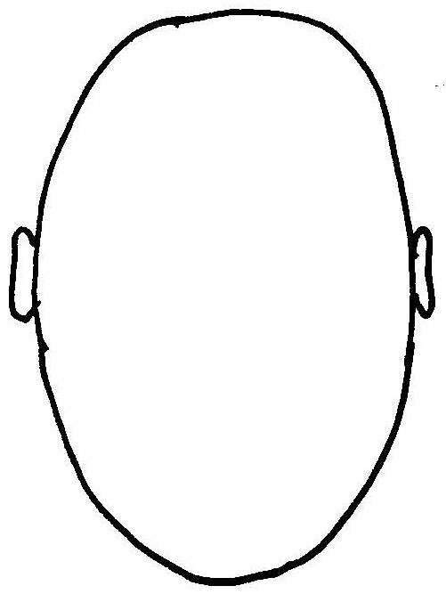
………………………………………………………………………………………...

………………………………………………………………………………….

………………………………………………………………………………

……………………………………………………………………………..

……………………………………………………………………………………………………………………………………………………….…..
Please see overleaf for advice on head injuries from http://bit.ly/NHSbump

We would be grateful if you would update us, should your child/ward
require Medical treatment. You can do this by emailing
cypadmin@quaker.org.uk or calling 020 7663 1013.

Make sure that an adult stays with your child/ward for at least the first 24 hours.

Regards

Signature of staff member | Printed name of staff member
Head injury and concussion
Most head injuries aren't serious. You don't usually need to go to hospital and should make a full recovery within 2 weeks.
After a head injury if your child/ward has any of the following symptoms go immediately to A&E:

- repeated vomiting.
- a headache that doesn’t go away with painkillers.
- a change in behavior, like being more irritable.
- problems with memory.
- a medical history such as a blood clotting disorder (like hemophilia) or take blood-thinners (like warfarin) or have had brain surgery in the past.
Symptoms usually start within 24 hours but sometimes may not appear for up to 3 weeks.
If you are unable to get them to A&E safely call 999.
Call 999 and ask for an ambulance if your child/ward experiences any of the following:

https://www.nhsinform.scot/illnesses-and-conditions/injuries/head-and-neck-injuries/minor-head-injury

- unconsciousness – either brief or for a longer period of time.
- difficulty staying awake or keeping their eyes open.
- a seizure (fit).
- problems with the senses – such as hearing loss or double vision.
- blood or clear fluid coming from the ears or nose or bruising behind their ears.
- numbness or weakness in part of their body.
- problems with walking, balance, understanding, speaking or writing.
How to treat a minor head injury at home. It’s normal to have symptoms such as a slight headache, or feeling sick or dazed for up to 2 weeks. To help recovery:

- hold an ice pack (or bag of frozen peas in a tea towel) to the injury regularly for short periods in the first few days to bring down any swelling.
- rest and avoid stress – you or your child do not need to stay awake if you are tired.
- take paracetamol to relieve pain or a headache – don’t use ibuprofen or aspirin as they could cause the injury to bleed.
- don’t send them back to school until they are feeling better.
- don’t play contact sports for at least 3 weeks, they should also avoid rough play for a few days.
- see a GP if your child / wards symptoms last more than 2 weeks.
- see a GP if you aren’t sure if it’s safe for them to return to school, sports or normal activities.

